Nanyang Technological University

**MA4830 – Realtime Software for Mechatronic Systems**

Minor Programming Assignment

Supervisor:

Prof. Gerald Seet

Student Name:

Jin Zihang U1822185F

Bryant U1820821E

Cai Yuxin U1822214D

Dylan Yeo U1922111H



Table of Contents

Description 3

Features 3

Highlight 3

Limitation 3

Flow Chart 4

Program Listing 5

Process controls 5

Example Run 8

Directory Tree 10

# Description

We wrote a C program to calculate the properties of standard 2D & 3D objects. The program guides users to choose and input appropriate parameters as shown in **Table 1,** then the output results will be tabulated and displayed onto the computer screen. This program can be executed multiple times for different geometries and the calculation results are stored in a history variable. The history table can be displayed as requested with means and standard deviations at the end of each column.

|  |  |  |  |  |  |  |  |  |
| --- | --- | --- | --- | --- | --- | --- | --- | --- |
| Keyboard Input | | | 🡺 | Output Result | | | | Display  Calculation history, Mean & SD |
| Class of object | Type of object | Unit | Circumference | Area | Surface area | Volume |
| 2D Objects | Rectangle | m  dm  cm  mm | √ | √ |  |  |
| Square | √ | √ |  |  |
| Circle | √ | √ |  |  |
| 3D Objects | Cuboid |  |  | √ | √ |
| Cube |  |  | √ | √ |
| Sphere |  |  | √ | √ |
| Cone |  |  | √ | √ |

*Table 1. Input and Output chart*

## Features

1. Allow users to select “Unit” for calculation (m, dm, cm, mm) and automatically execute unit conversions and present requested calculation result in table format.
2. Allow users to do multiple calculations in sequence without exiting the program.
3. Users can real-time check the input parameters they have.
4. Users can backtrack while choosing a geometry to change the dimension of the geometry that they would like.
5. Allow users to “Exit” program when selecting a geometry or after calculation.
6. The program is also able to identify input errors and give out case-by-case help.
7. Ability to calculate properties for multiple geometries and calculate means and standard deviations.
8. Ability to display all previous calculation history in table format after every calculation.
9. Clean output display with the usage of “=” and every round of calculations are separated neatly for ease of reading.

## Highlight

1. Multiple files contain different functions for modularity purposes and easier-to-understand logic.
2. Enum and Struct to encapsulate a group of data with similar properties.
3. Usage of dynamic memory allocation to store the user’s input and will be freed after usage.

## Limitation

1. The variables (Length, Width, Area, Volume, etc.) are defined as doubles. If input max length and width to calculate area, it will exceed the memory allocation of the program.
2. The history table only contains a maximum of 10 recently calculated data for each geometry.

# **Flow** Chart

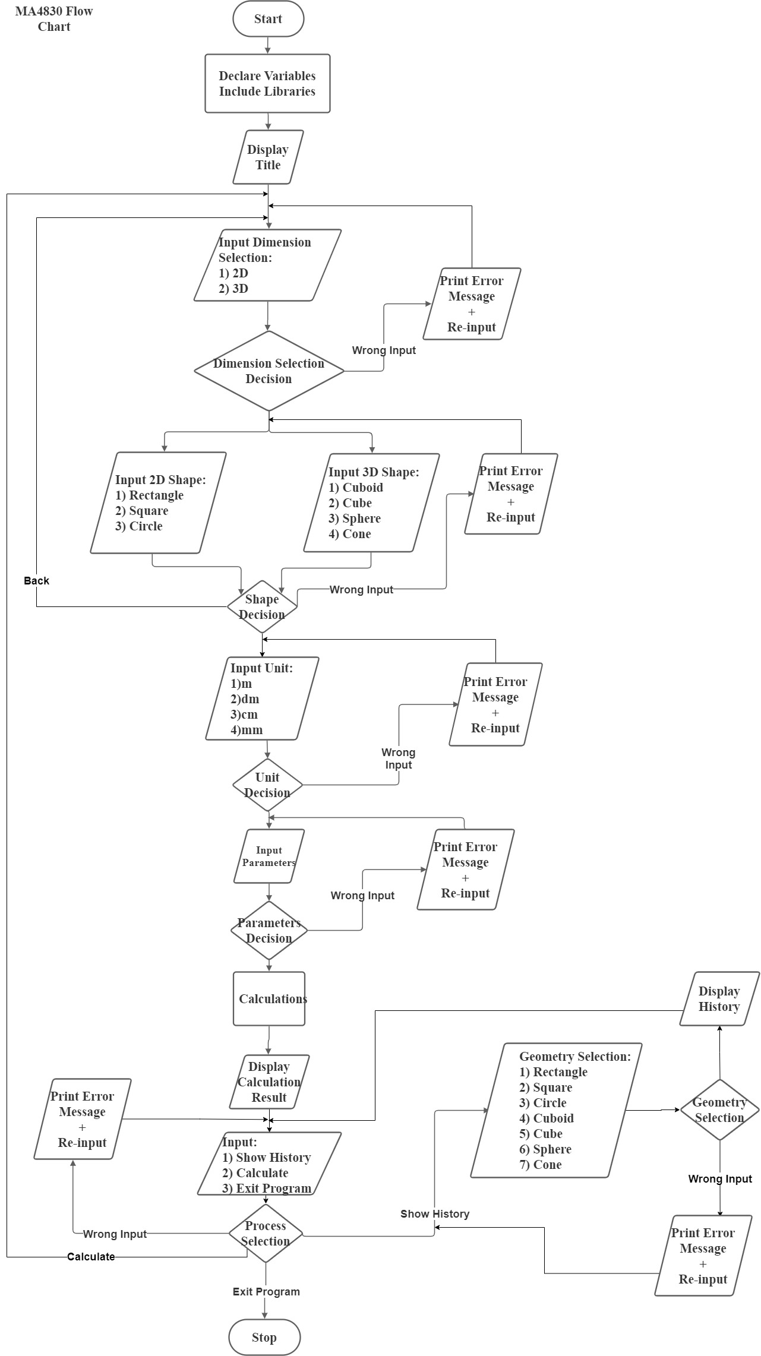

*Table 2. Overall Flowchart*

# Program Listing

The **Table 3** below shows all self-defined functions in the program and are separated into 4 categories. And below shows some key functions programming logic and method used to improve the ease of use and robustness of the whole program.

|  |  |
| --- | --- |
| Input & Process controls |  |
| Help & Suggestions printed |  |
| Calculation & Visualization |  |
| History and Mean & SD Display |  |

*Table 3. Categories of all functions*

## Process controls

1. The program logic of self-defined function **UnitSelection()** [**ProcessSelection()** is similar to this logic].

*Table 4. Programming Logic for UnitSelection()*

1. The program logic of self-defined function: **GeometrySelection()**, **ShapeSelection()** and **ObjectSelection()**.

*Table 5. Programming Logic for GeometrySelection()*

1. The program logic of self-defined function **DimensionSelection()**.

*Table 6. Programming Logic for DimensionSelection()*

# Example Run

|  |  |
| --- | --- |
| Screenshots | Description |
|  | * Main title screen * 3 choices: 1)” 2D”/”1” 2)”3D”/”2” 3)”Exit” |
|  | * 2D shapes: 1) Rectangle 2) Square 3) Circle |
|  | * 3D objects: 1) Cuboid 2) Cube 3) Sphere 4) Cone |
|  | * An error message will be sent if there is an invalid input |
|  | * “Enter positive number” message sent if the input is “0” or negative number |
|  | * “Back” command to change the dimension of geometry |
|  | * Input Units: 1) m 2) dm 3) cm 4) mm |

|  |  |
| --- | --- |
|  | * Request for parameters (Width, Length) * Display of calculation results in table form * Select: 1) History 2) Calculate 3) Exit   after calculation |
|  | * Select history geometries: 1) Rectangle 2) Square 3) Circle 4) Cuboid 5) Cube 6) Sphere 7) Cone * Display of 2D shapes’ calculation history in table form * Mean and SD calculated |
|  | * Display of 3D objects’ calculation history in table form * Mean and SD calculated |

# Directory Tree

|  |  |
| --- | --- |
| **Files** | **Description** |
| Main.c | Execute Main programme |
| Title.txt | Contains Main Screen of geometry calculator |
| Enum.h | Contains enum of geometries and units |
| Struct.h | Contains parameters and their respective data types |
| Calculation.h | Contains formulas for calculation |
| Print.h | To print tables and the relevant results |
| Selection.h | To give the user choices for different inputs |

*Table 7. Descriptions of file directories*